#### Viewing Workflows & Creating Steps

[Echoes - Land Management](https://echoes-platform.eu/app/main/map-view)

19 Steps

Go to <https://echoes-platform.eu/>

1 - View all Workflows

Clicking on the 'Workflow' tab will take you to a view to see all Requests created for all your sites.

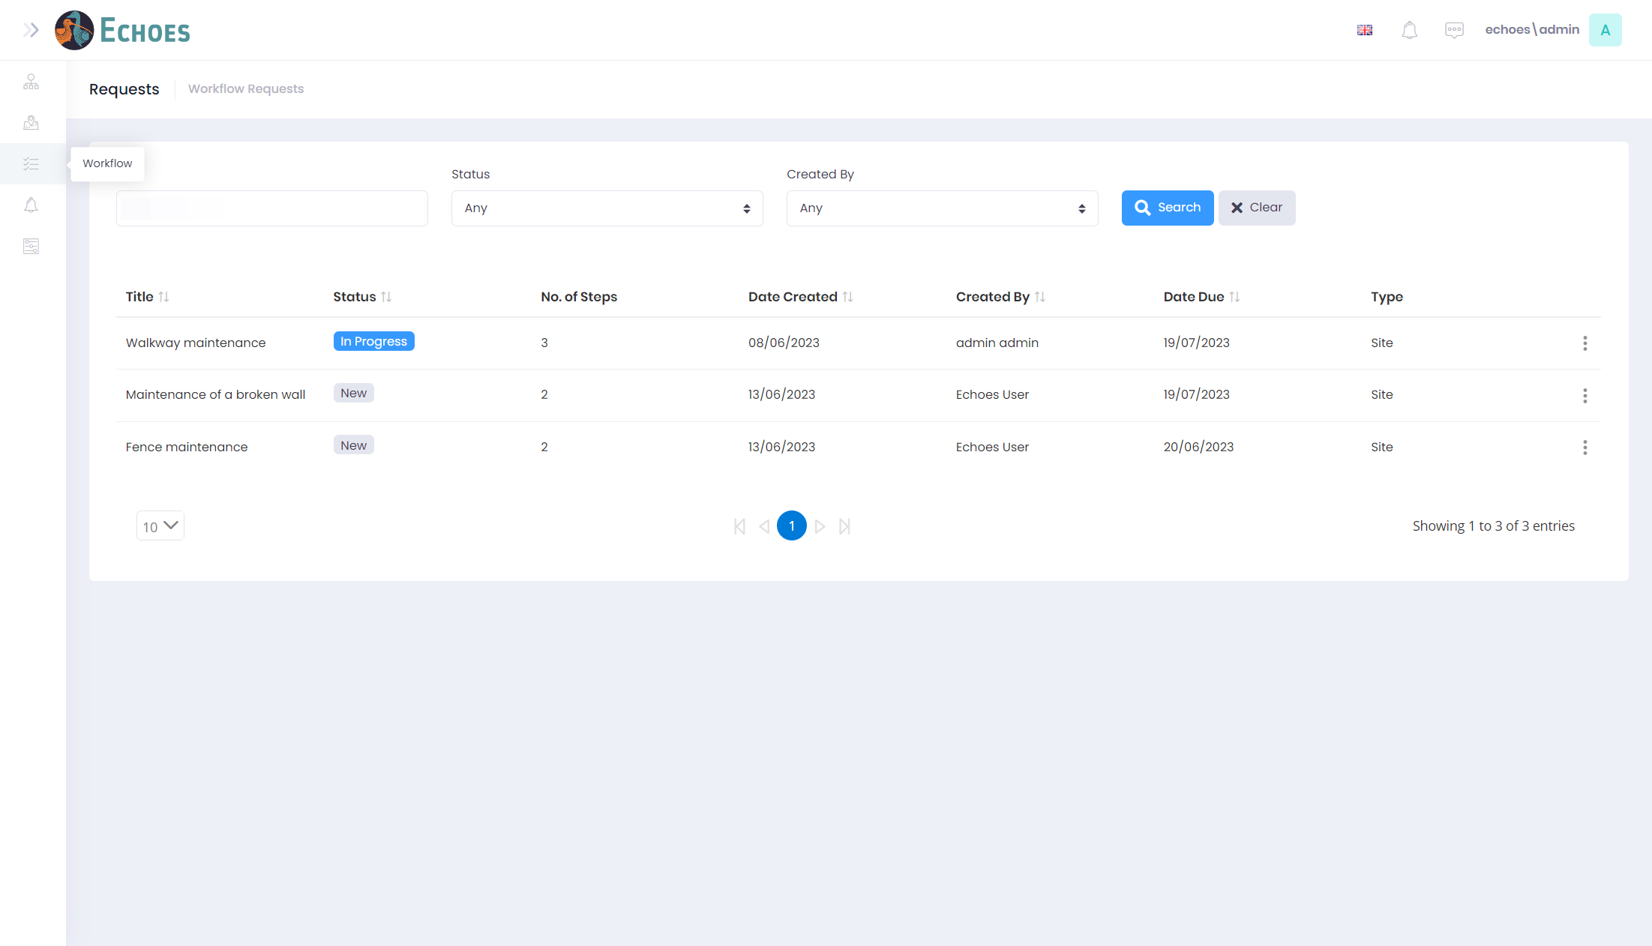

2 - Filtering on your Requests (1/2)

You can filter on your requests by searching for partial matched to your description then clicking the 'Search' button.

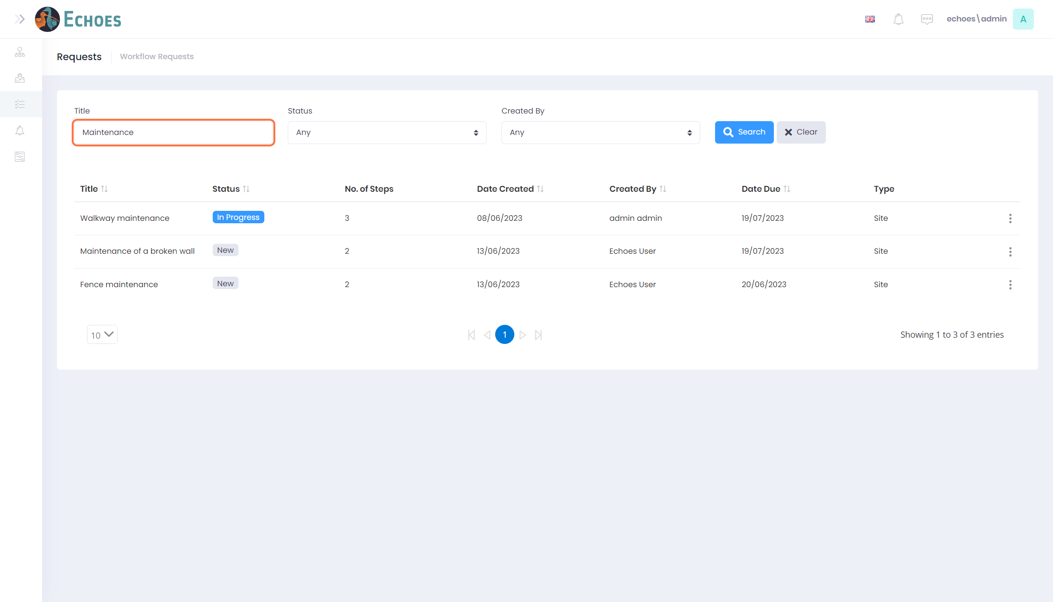

3 - Filtering on your Requests (2/2)

Or by selecting from the drop downs in 'Status' or 'Created By' then clicking the 'Search' button.

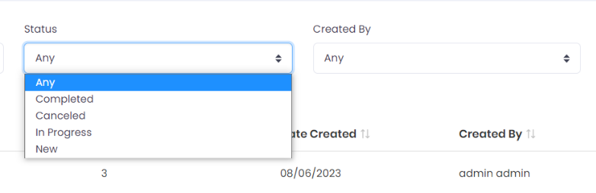

4 - Search Button

You must click this 'Search' button for any of your filters to become active. The 'Clear' button will remove any filters you have set.

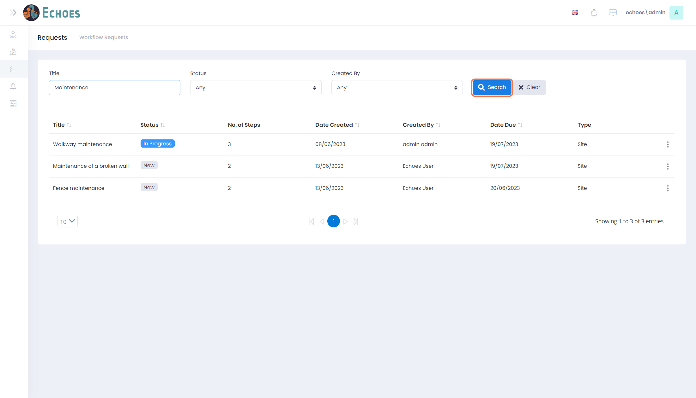

5 - Navigating to Steps

You can get to steps by clicking on the ellipsis's icon of the request' steps you want to see, then choosing the 'Steps' option.

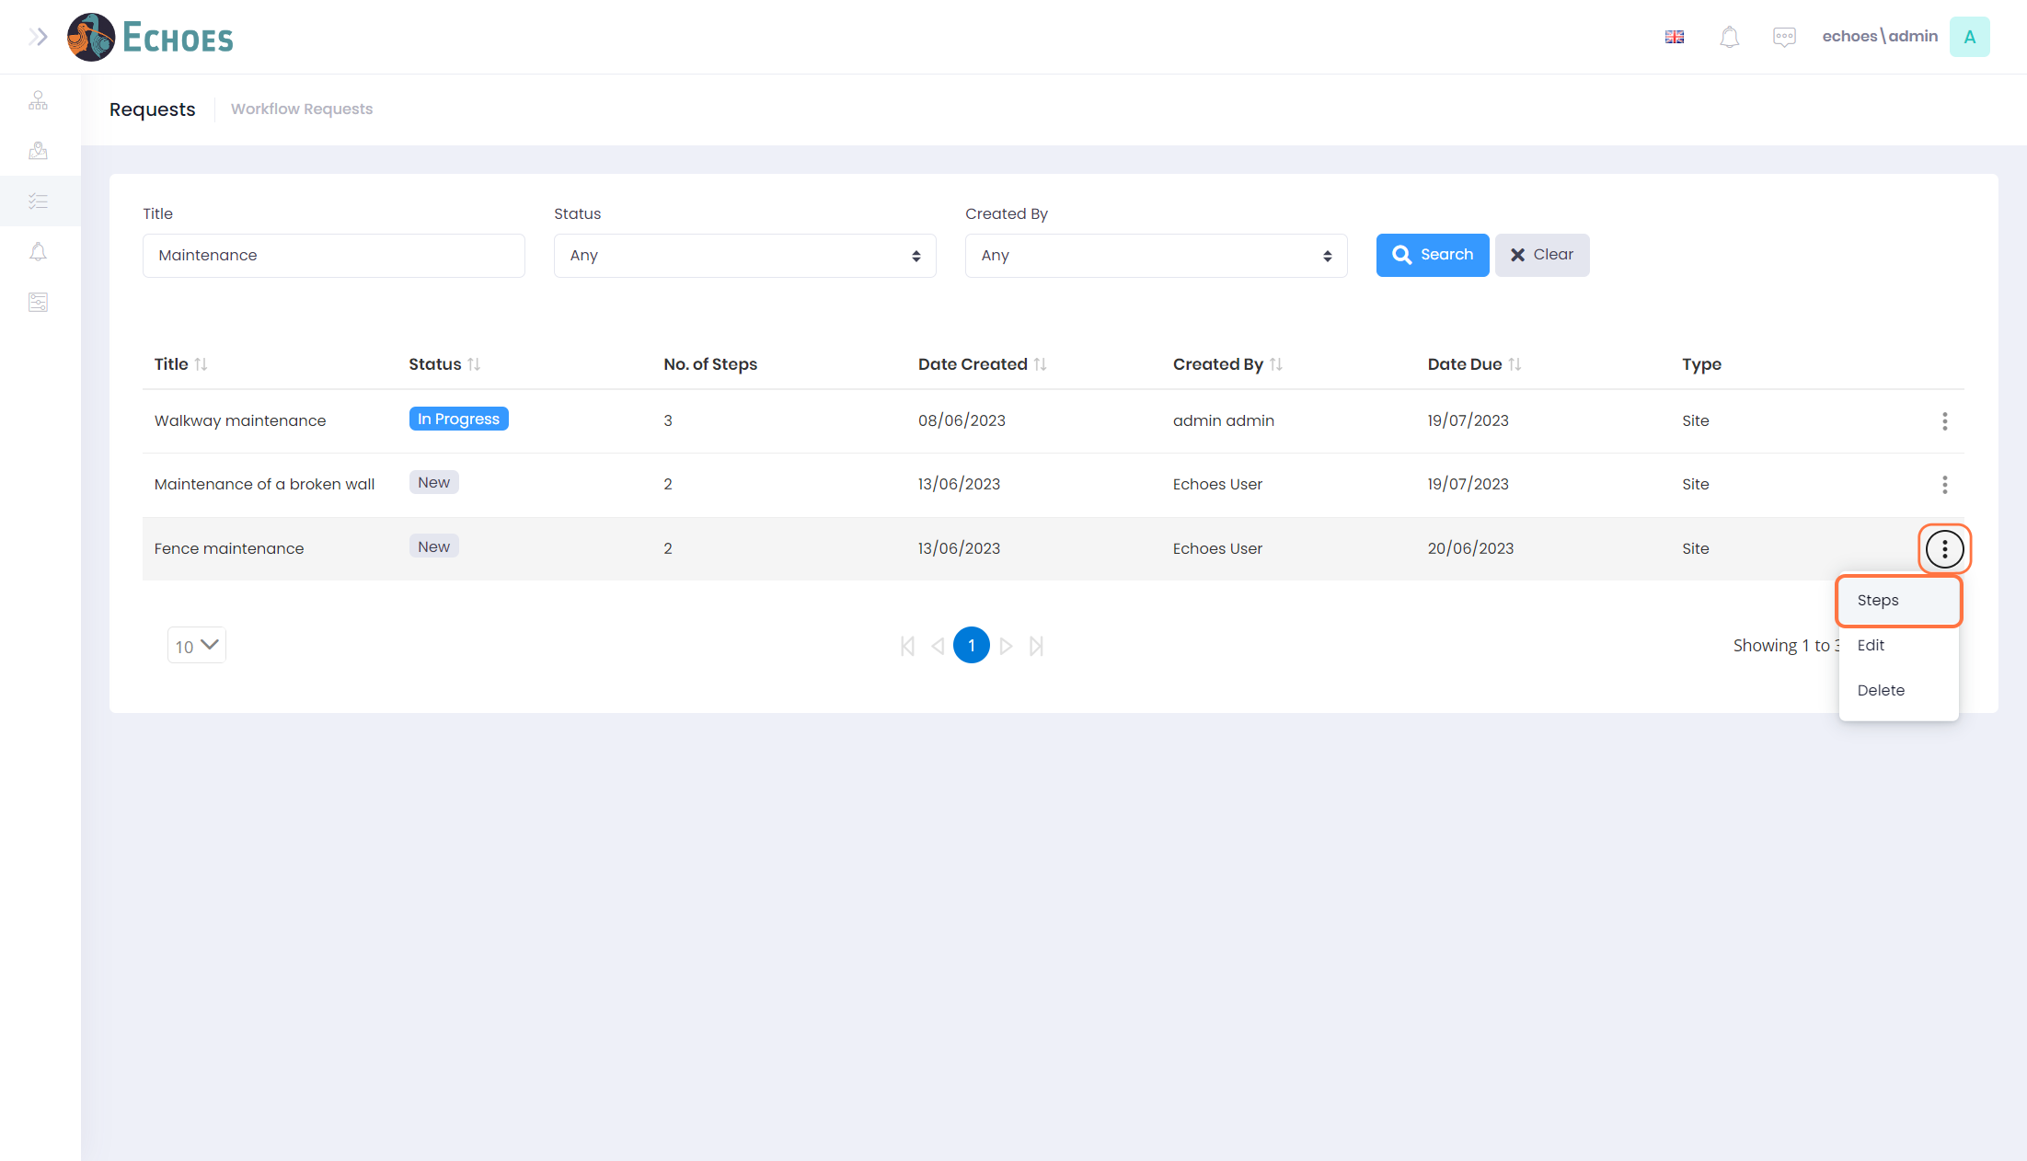

6 - Viewing & Creating a Steps

You can now see all the steps within your chosen request. The same filtering as the requests applies here.

To create a new step, click the 'Create new step' button in the top right.

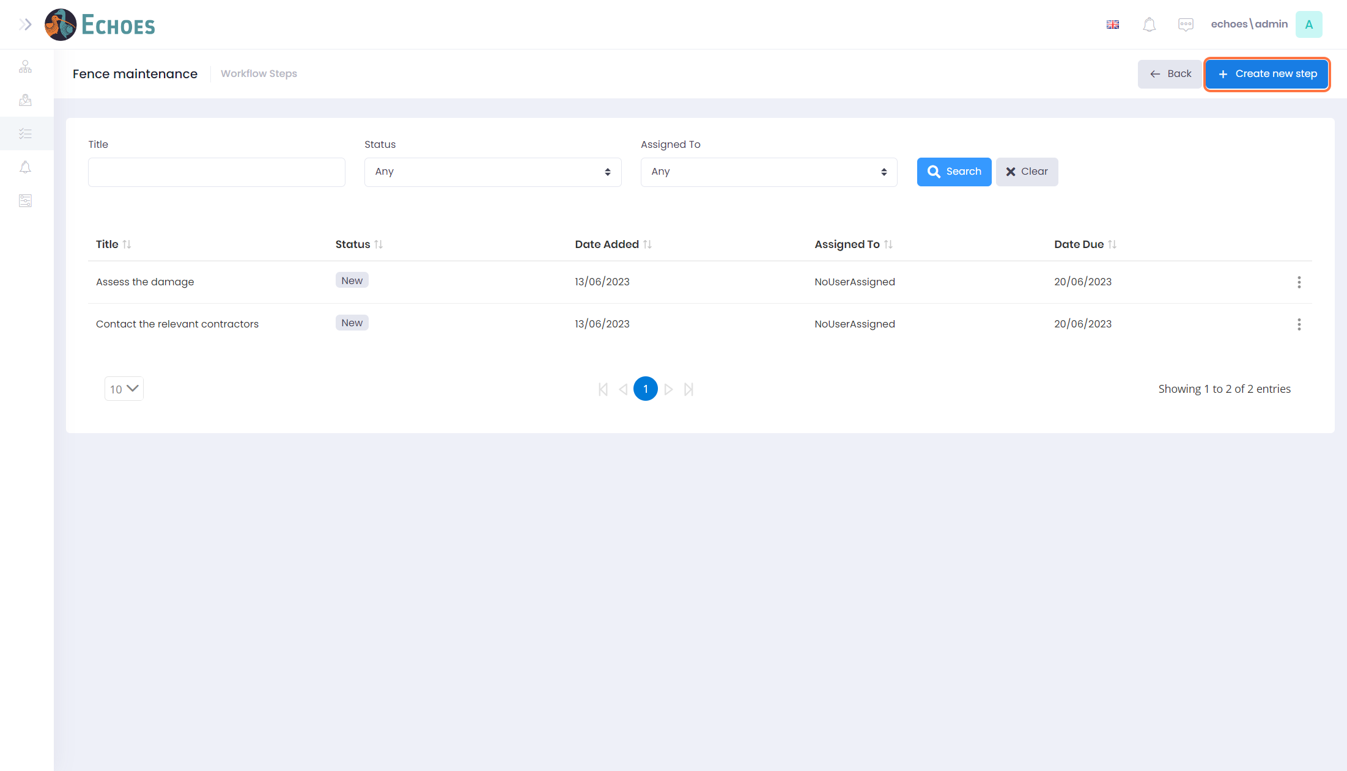

7 - Create Step form

The 'Create Step' form will now appear.

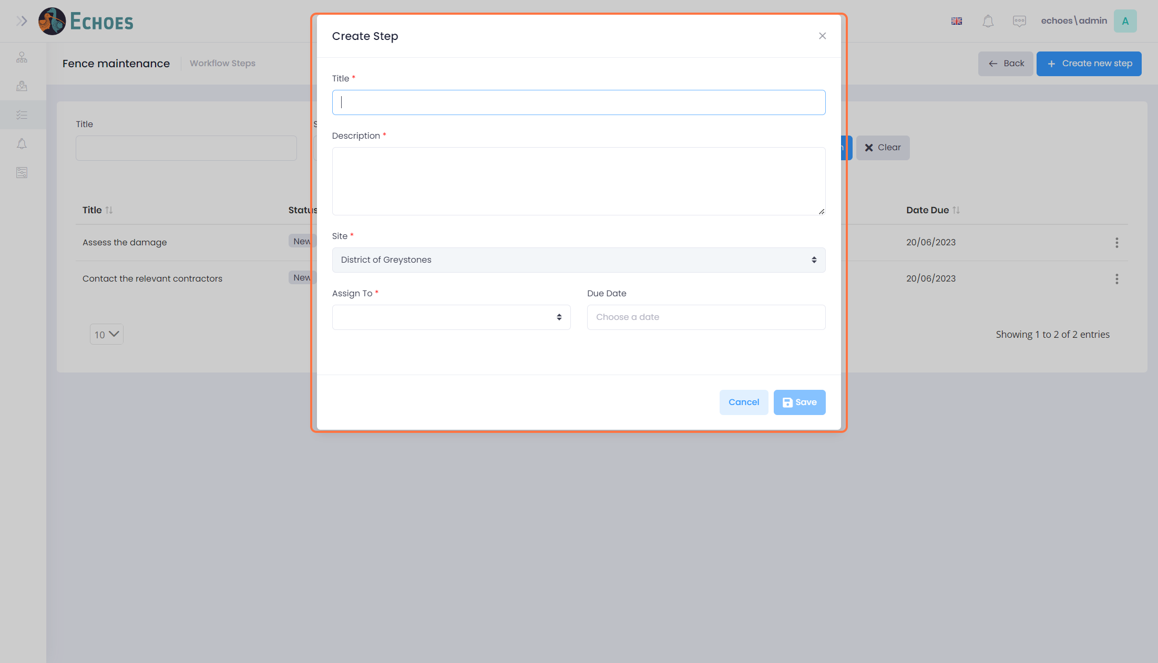

8 - Complete the 'Create Step' form (1/4)

Start by giving the step a title.

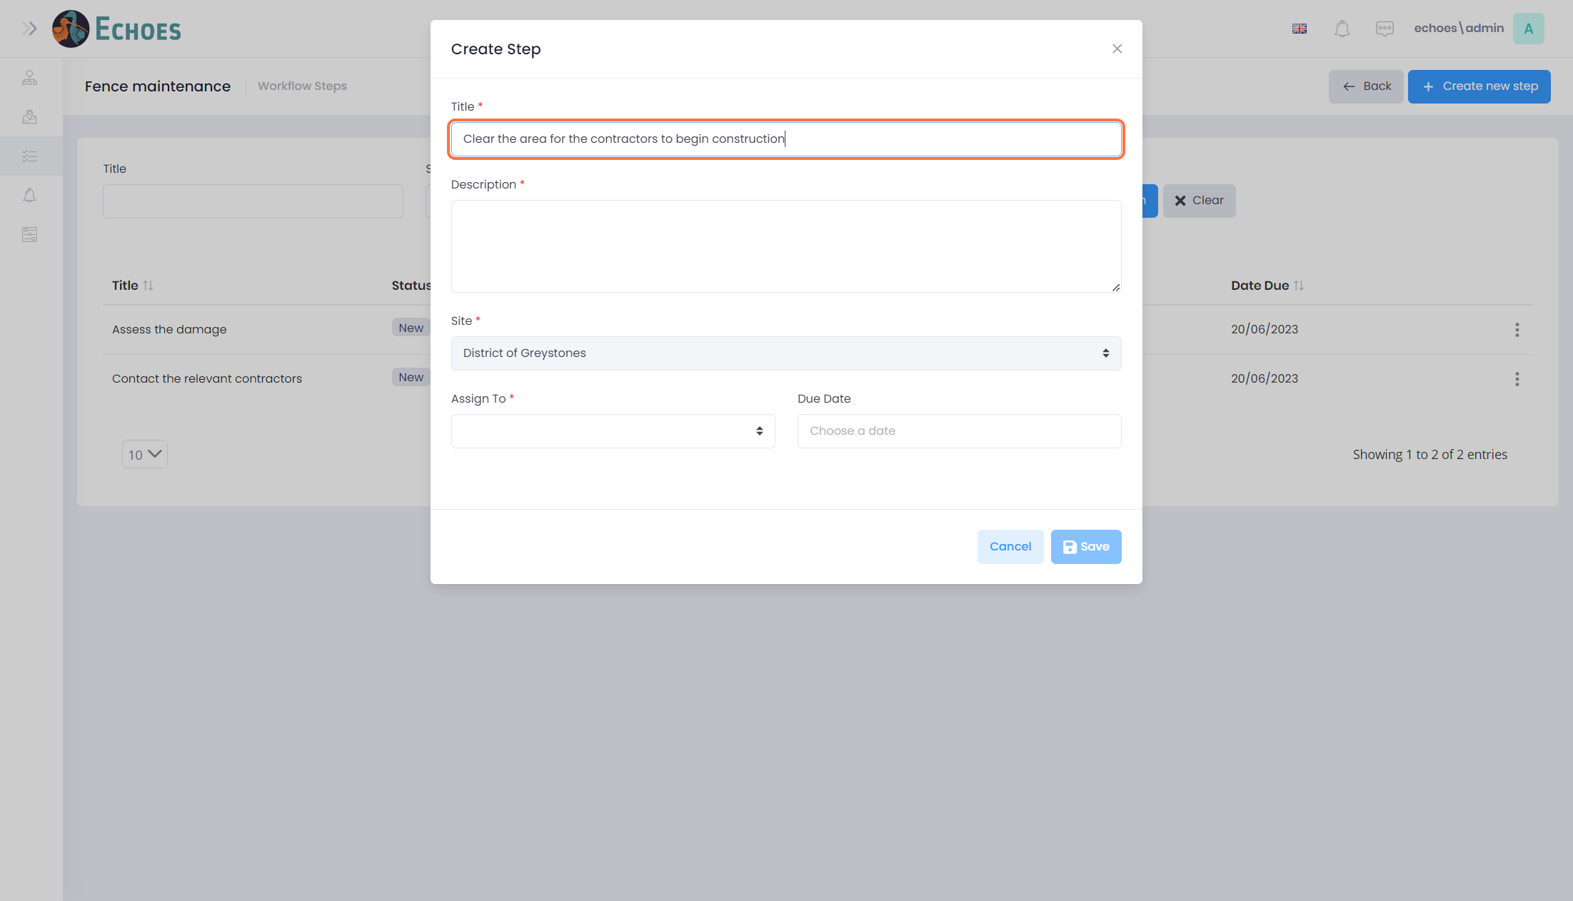

9 - Complete the 'Create Step' form (2/4)

Start by give the step a description.

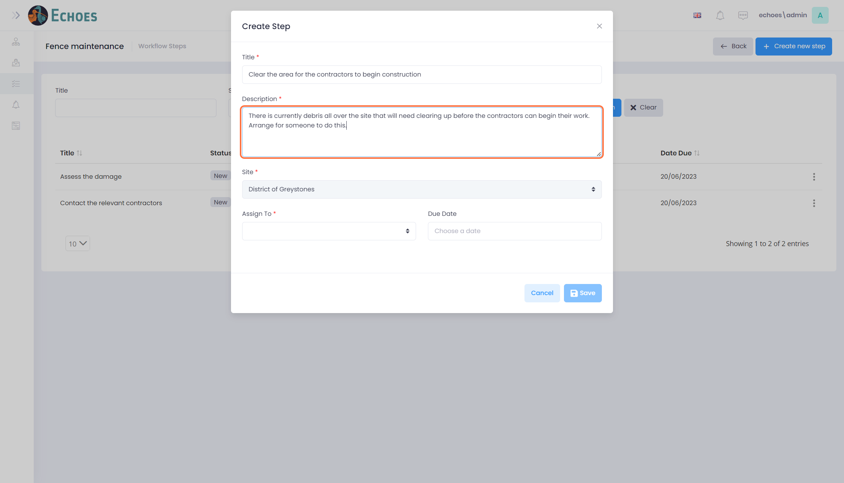

10 - Complete the 'Create Step' form (3/4)

Then choose who to assign the step to.

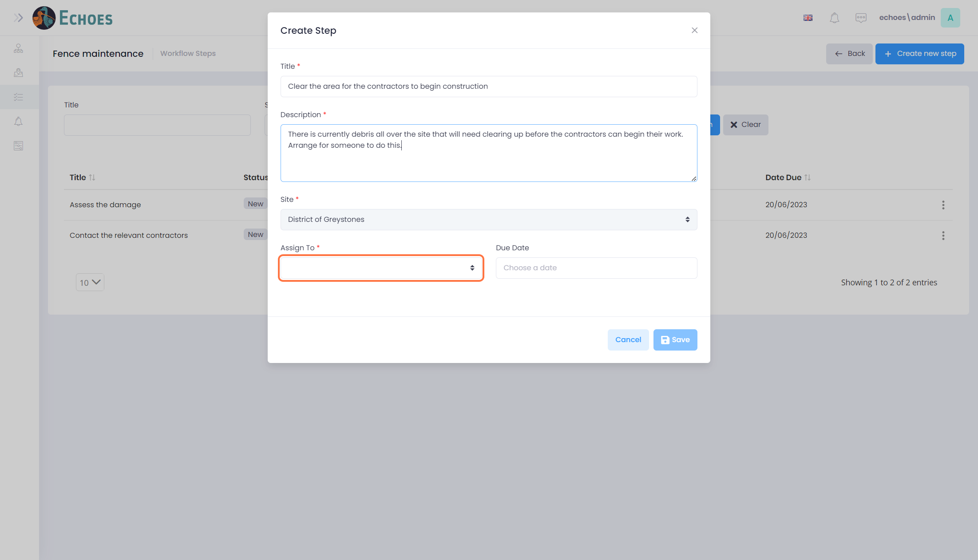

11 - Complete the 'Create Step' form (4/4)

Choose a Due date for the step (Not mandatory)

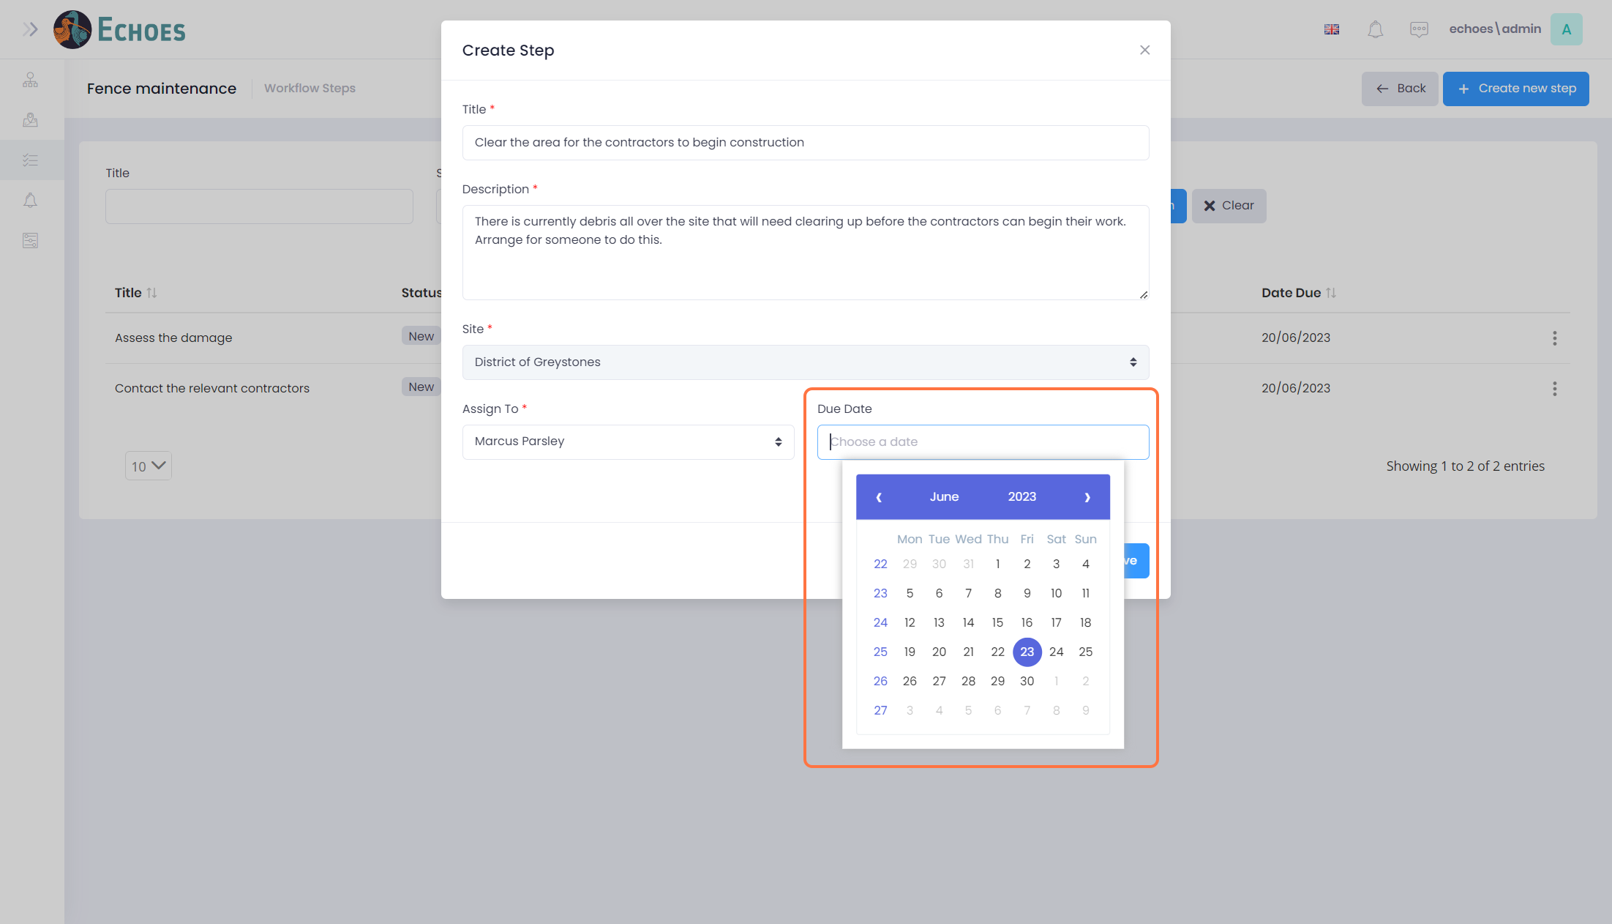

12 – Save the Step

Once you are happy with the step, click the 'Save' button.

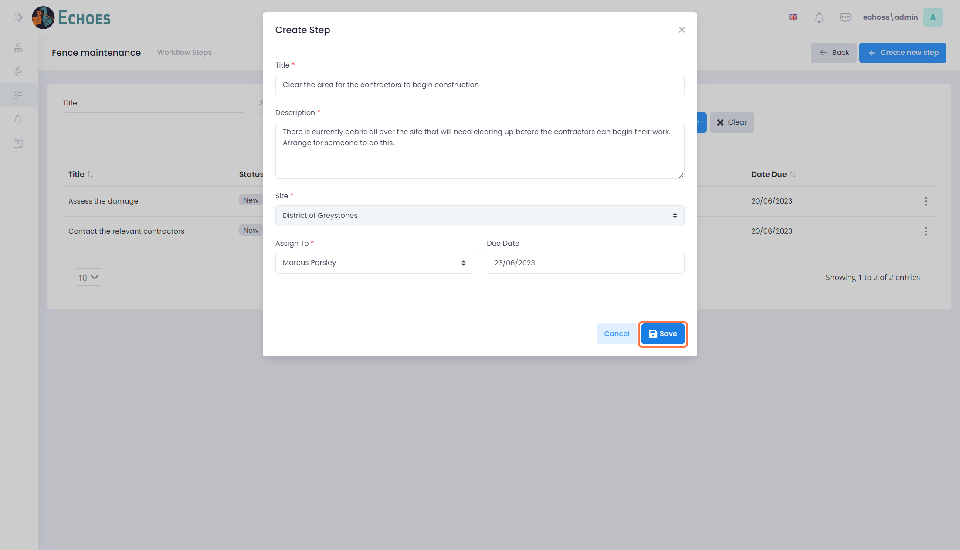

13 - New Step in the Data table

You will now see the new step in the Data table.

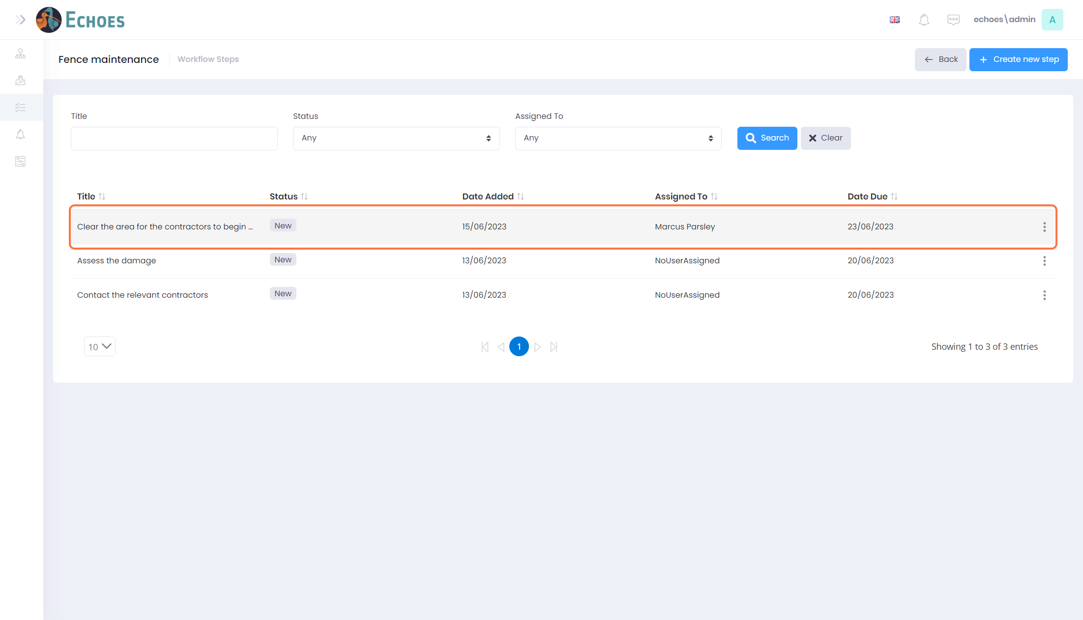

14 - Editing a Step

To edit a step, click on the steps' ellipses you want to edit, then click the 'Edit' option.

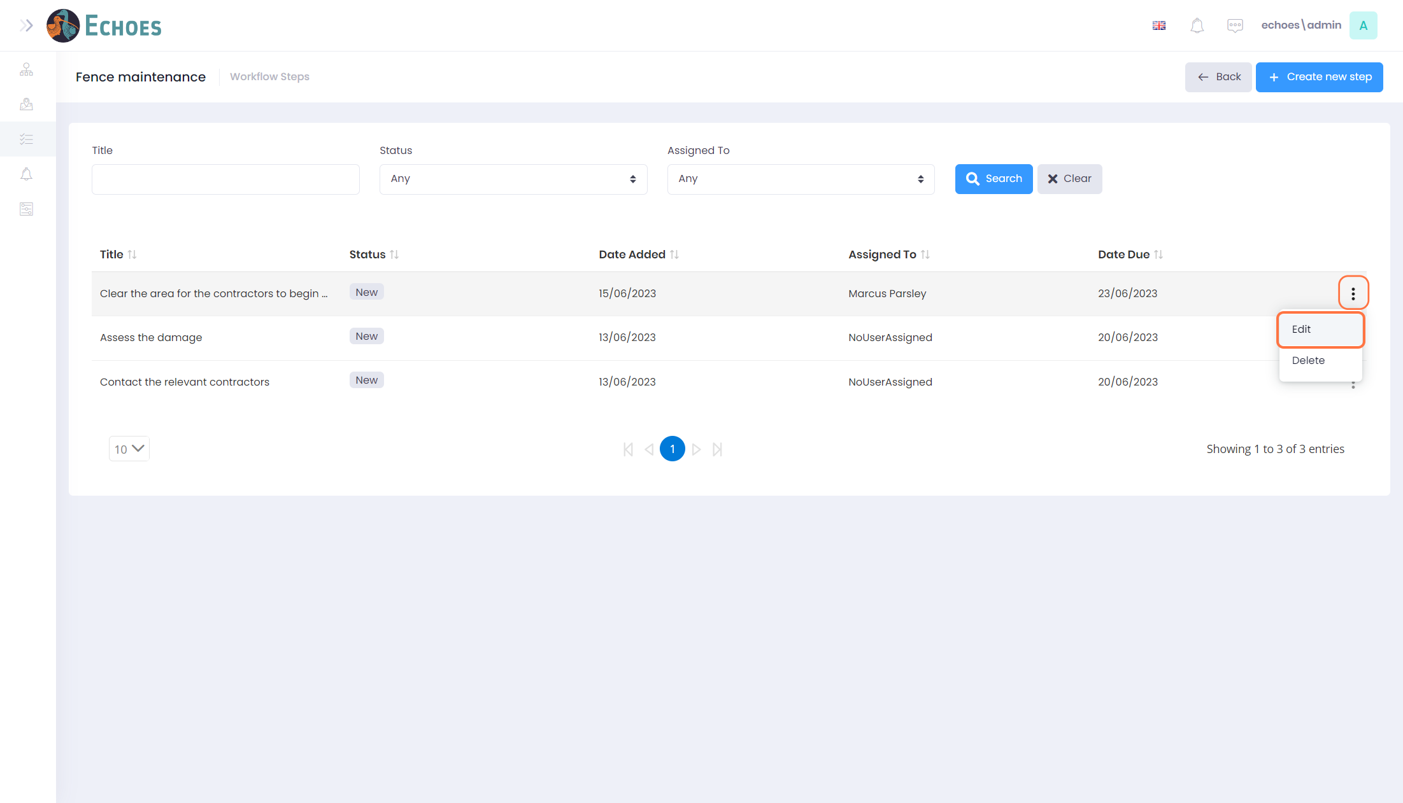

15 - Editing the information of a Step

You can change the information within the step, such as the Status.

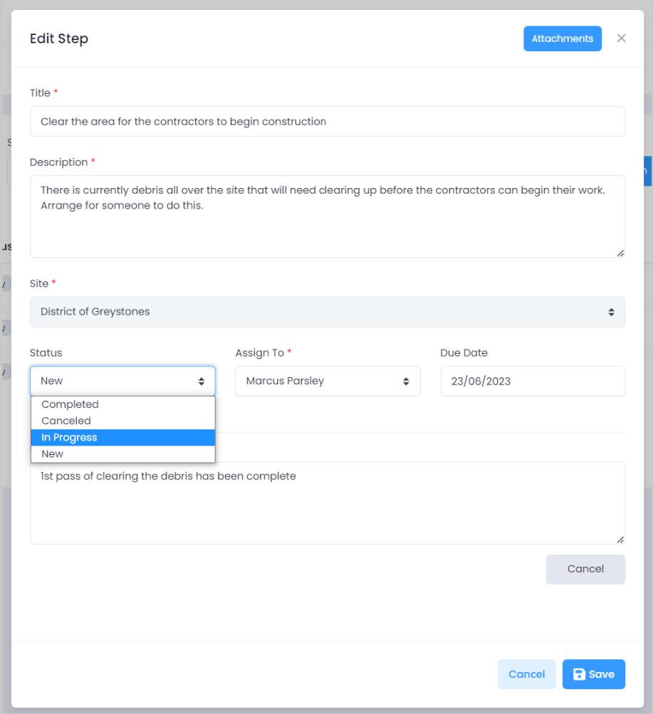

16 - Adding a Comment

To add a comment, click the 'Add' button to start.

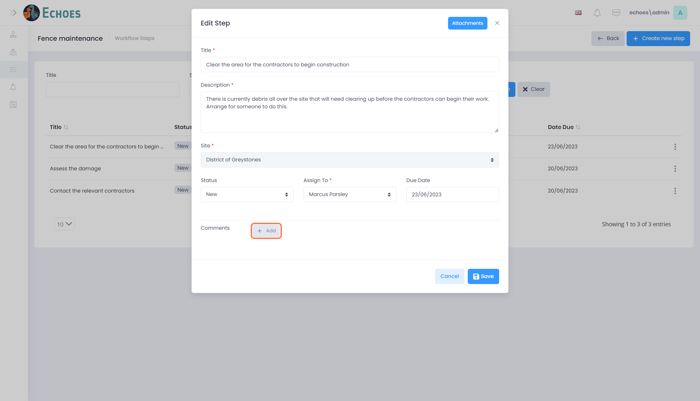

17 - Enter the Comment

You can now enter the comment you wish to leave. This comment will be saved when you save the edit.

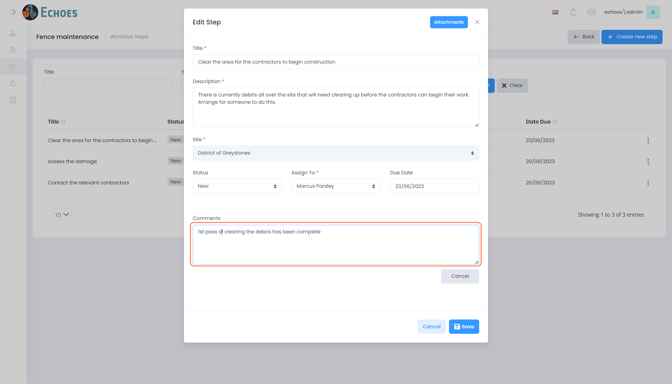

18 - Saving the Edit

Once you have completed your edits, click on the 'Save' button.

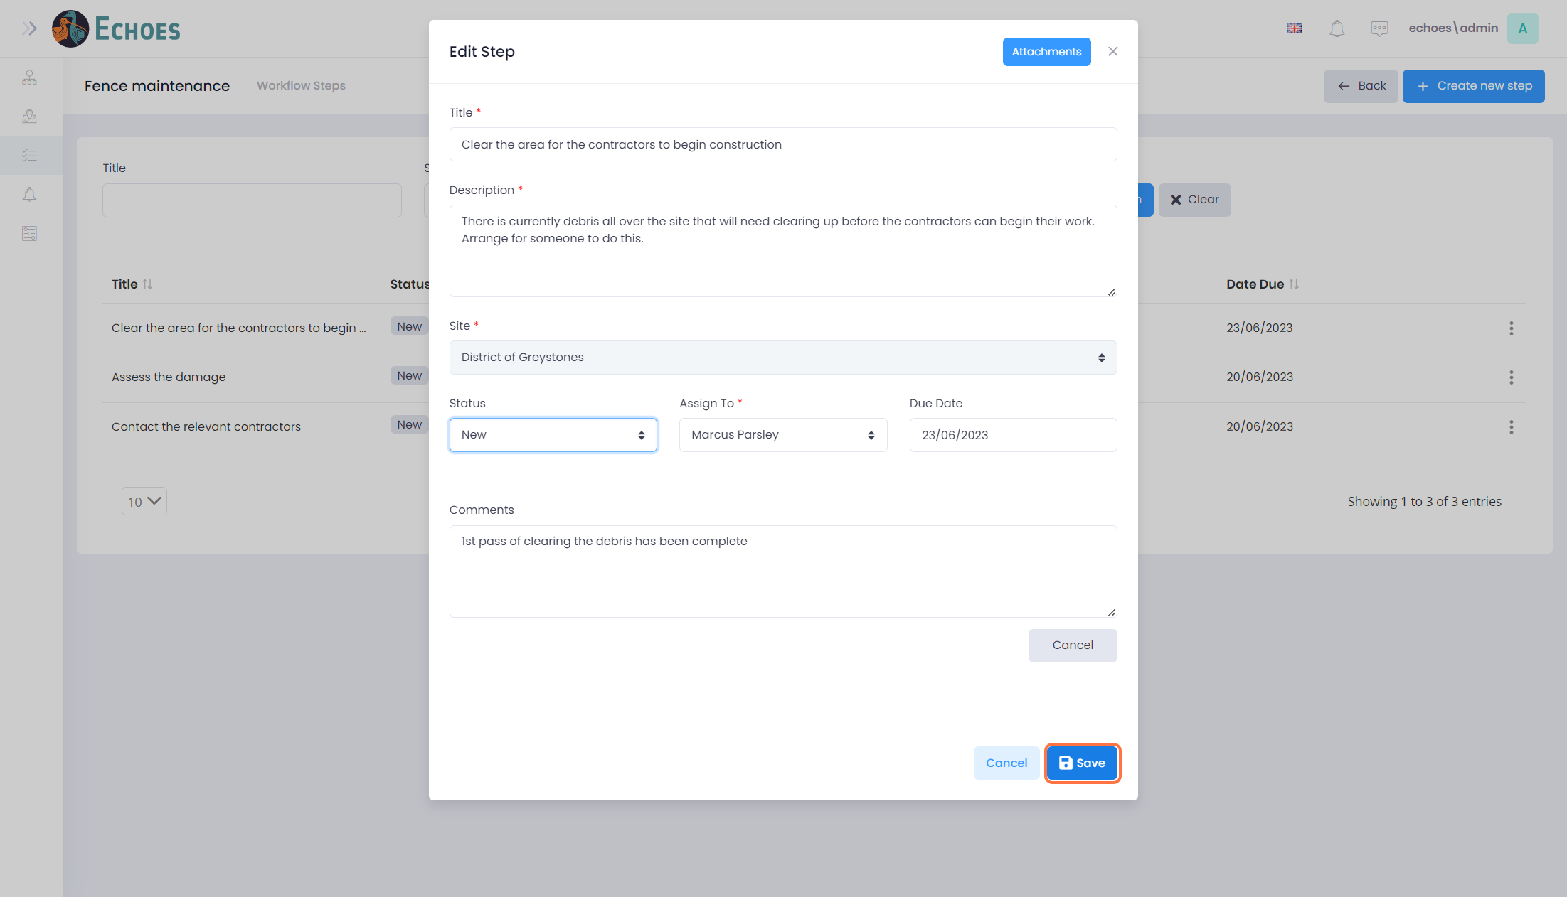

19 - View the Changes

You will now see that the changes to the status have made a change in the data grid. The status 'In Progress' is now showing.

